**1.User Requirements**

The user requirements for the a new building with four storey has provision to install two lifts.

**1.1 Functional Requirements**

* The user should be able to select the floor to go
* The lift should allow the user to stop the lift in the middle
* The lift should carry at least 1000 kg in weight
* The user should be able to move up and down
* The user has to able to close/open the gate of the lift
* The lift should start only after closing the door

**1.2 Non functional Requirements**

* The user should be able to ring an alarm in case of emergency
* The user should be able to know when the lift is overweight
* The lift should be wide enough for a stretcher
* There should be remainder for closing the door after the person enters
* The lift should have a fan for cooling
* The lift should have support for downtime for at least 1 hour

**2.System Requirements**

The system requirements are specified for the project

* The lift needs to have a door to enter ceiling to provide maintenance
* The lift needs to work for at least 2 years reliably.
* The lift has to have proper ventilation
* The lift needs to support multiple people

Use Case Diagram

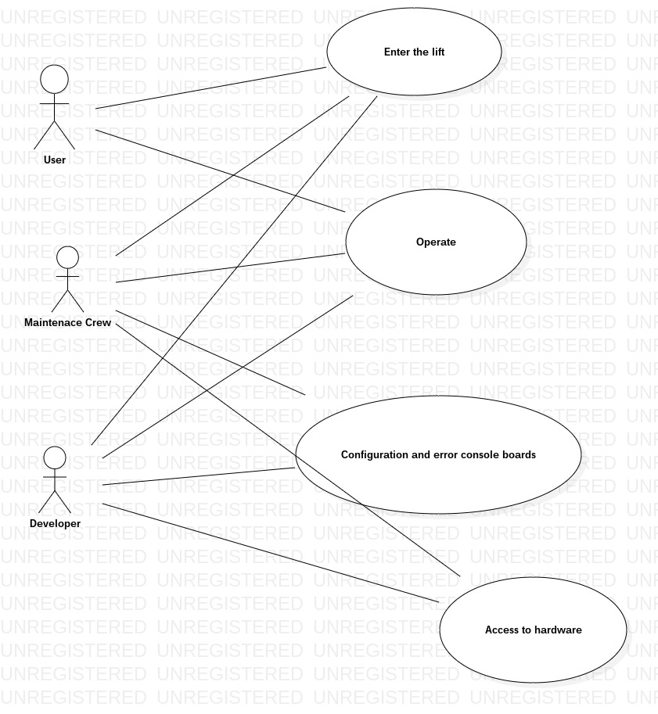

Sequence Diagram

